## Heaven’s Light is our Guide

# Rajshahi University of Engineering &Technology



*Department of Electronics & Telecommunication Engineering*

**Course No.:** IPE 4261

**Course Title:** Project Planning and Legal Issues.

**A Project Report on**

**Home Automation Project Using Android Application.**

|  |  |
| --- | --- |
| **Submitted By:**  **Pratik Barua**  **Roll no: 1604055**  **4th Year, Even semester**  **Date: 14th September, 2022** | **Submitted To:**  **Khairun Nahar**  **Assistant Professor**  **Dept. of IPE**  **RUET** |

**Home Automation Project Using Android Application**

Abstract

The main objective of this project is to develop a home automation system using a microcontroller with Bluetooth module being remotely controlled by any Android OS smart phone. As technology is advancing so houses are also getting smarter. Modern houses are gradually shifting from conventional switches to centralized control system, involving remote controlled switches. Presently, conventional wall switches located in different parts of the house makes it difficult for the user to go near them to operate. Even more it becomes more difficult for the elderly or physically handicapped people to do so. Remote controlled home automation system provides a most modern solution with smart phones.

In order to achieve this, a Bluetooth module is interfaced to the microcontroller at the receiver end while on the transmitter end, an application on the cell phone sends ON/OFF commands to the receiver where loads are connected. By touching the specified location on the GUI, the loads can be turned ON/OFF remotely through this technology. The loads are operated by microcontroller through opto-isolators and thyristors using triacs.

**CONTENTS**

|  |  |
| --- | --- |
| INTRODUCTION | 4 |
| PROJECT AIM & SCOPE | 4 |
| DESCRIPTION OF PROJECT | 5 |
| HARDWARE REQUIREMENT | 5 |
| SOFTWARE REQUIREMENT | 6 |
| DESCRIPTION OF HARDWARE REQUIRED | 6 |
| INTERFACING OF HC-05 MODULE | 8 |
| DESIGN & IMPLEMENTATION | 12 |
| COST ANALYSIS | 15 |
| EXPLANATION OF COST OPTIMIZATION | 16 |
| ADVANTAGES OF HOME AUTOMATION | 17 |
| DISADVANTAGES OF HOME AUTOMATION | 17 |
| APPLICATIONS | 18 |
| UPGRADATIONS | 18 |
| CONCLUSION | 18 |
| REFERENCE | 19 |

Introduction

Nowadays, we have remote controls for our television sets and other electronic systems, which have made our lives real easy. Have you ever wondered about home automation which would give the facility of controlling tube lights, fans and other electrical appliances at home using a remote control? Off-course, Yes! But, are the available options cost-effective? If the answer is No, we have found a solution to it. We have come up with a new system called blutooth based home automation using microcontroller.

This system is super-cost effective and can give the user, the ability to control any electronic device without even spending for a remote control. This project helps the user to control all the electronic devices using his/her smartphone.

Time is a very valuable thing. Everybody wants to save time as much as they can. New technologies are being introduced to save our time. To save people’s time we are introducing Home Automation system using Bluetooth . With the help of this system you can control your home appliances from your mobile phone. You can turn on/off your home appliances within the range of Bluetooth.

Project Aim

The aim of the project is to design and construct a home automation system that will remotely switch on or off any household appliances connected to it, using a microcontroller, voice dial on phone , or Bluetooth based application.

Project Objective

The objective of this project is to implement a low cost , reliable and scalable home automation system that can be used to remotely switch on or off any household appliance , using a microcontroller to achieve hardware simplicity ,low cost short messaging service for feedback and voice dial from any phone to toggle the switch state.

Project scope and limitation

This project work is complete on its own in remotely and automatically switching on or off of an electrical appliance not limited to household appliances and sends a feedback message indicating the new present state of the appliance.

Description of the Project

This project is one of the important microcontroller Projects. Microcontroller based home automation using Bluetooth project helps the user to control any electronic device using Device Control app on their Android Smartphone. The android app sends commands to the controller – Microcontroller, through wireless communication, namely, Bluetooth. The microcontroller is connected to the main PCB which has five relays as shown in the block diagram. These relays can be connected to different electronic devices.

When the user presses on the ‘On’ button displayed on the app for the device 1, the Light is switched on. This Light can be switched off, by pressing the same button again.

Similarly, when the user presses on the ‘On’ button displayed on the app for the device 2, the Light is switched on. The Light can be switched off, by pressing the same button again.

This project of home automation using Bluetooth and microcontroller can be used for controlling any AC or DC devices. In the demonstration, we have used AC Bulb. To drive this Lights AC supply is connected.

Hardware Requirement

The list of components mentioned here are specifically for controlling 4 different loads.

 ➢ Atmega 328P microcontroller

 ➢ HC – 05 Bluetooth Module

 ➢ 10 mf capacitor

 ➢ Voltage regulator

 ➢ 16 MHz crystal Oscillator

 ➢ 22 pf capacitor X 2

 ➢ 5 V Relay X 5

 ➢ Prototyping board (Bread board)

 ➢ Connecting wires

 ➢ AC Power supply

 ➢ Smartphone or tablet (Bluetooth enabled)

Software Requirement

➢ Arduino 1.8.8 compiler

➢ Proteus 7

➢ Android application

Description of Hardware Required

Atmega 328P Microcontroller

The **ATmega328** is a single-[chip](https://en.wikipedia.org/wiki/Integrated_circuit) [microcontroller](https://en.wikipedia.org/wiki/Microcontroller) created by [Atmel](https://en.wikipedia.org/wiki/Atmel) in the [megaAVR](https://en.wikipedia.org/wiki/MegaAVR) family (later [Microchip Technology](https://en.wikipedia.org/wiki/Microchip_Technology) acquired Atmel in 2016). It has a [modified Harvard architecture](https://en.wikipedia.org/wiki/Modified_Harvard_architecture) [8-bit](https://en.wikipedia.org/wiki/8-bit) [RISC](https://en.wikipedia.org/wiki/Reduced_instruction_set_computer) processor core.

The Atmel [8-bit](https://en.wikipedia.org/wiki/8-bit) [AVR](https://en.wikipedia.org/wiki/Atmel_AVR) [RISC](https://en.wikipedia.org/wiki/Reduced_instruction_set_computing)-based microcontroller combines 32 kB [ISP](https://en.wikipedia.org/wiki/In-system_programming) [flash](https://en.wikipedia.org/wiki/Flash_memory) memory with read-while-write capabilities, 1 kB [EEPROM](https://en.wikipedia.org/wiki/EEPROM), 2 kB [SRAM](https://en.wikipedia.org/wiki/Static_random-access_memory), 23 general purpose I/O lines, 32 general purpose working [registers](https://en.wikipedia.org/wiki/Processor_register), three flexible timer/[counters](https://en.wikipedia.org/wiki/Counter_(digital)) with compare modes, internal and external [interrupts](https://en.wikipedia.org/wiki/Interrupt), serial programmable [USART](https://en.wikipedia.org/wiki/USART), a byte-oriented 2-wire serial interface, [SPI](https://en.wikipedia.org/wiki/Serial_Peripheral_Interface_Bus) serial port, 6-channel 10-bit [A/D converter](https://en.wikipedia.org/wiki/A/D_converter) (8-channels in [TQFP](https://en.wikipedia.org/wiki/Quad_Flat_Package) and [QFN](https://en.wikipedia.org/wiki/Quad_Flat_No-leads_package)/[MLF](https://en.wikipedia.org/wiki/Quad-flat_no-leads_package#Variants) packages), programmable [watchdog timer](https://en.wikipedia.org/wiki/Watchdog_timer) with internal [oscillator](https://en.wikipedia.org/wiki/Electronic_oscillator), and five software selectable power saving modes. The device operates between 1.8-5.5 volts. The device achieves throughput approaching 1 [MIPS](https://en.wikipedia.org/wiki/Million_instructions_per_second#Million_instructions_per_second) per MHz.

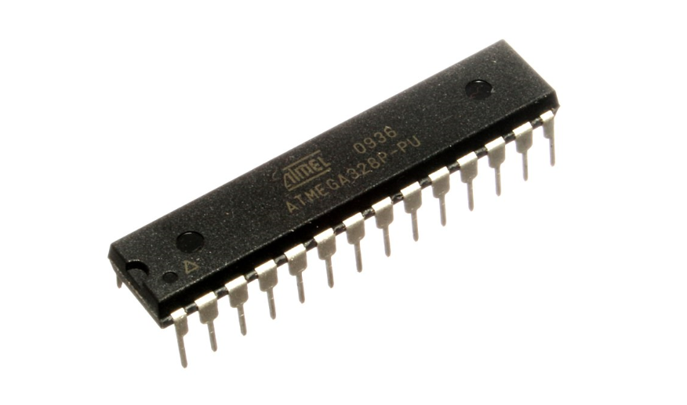

Pin Diagram of ATmega 328p Microcontroller

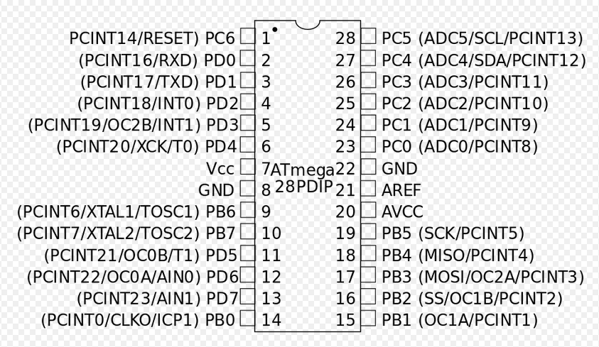

HC-05 Bluetooth Module

HC-05 module is an easy to use Bluetooth SPP (Serial Port Protocol) module, designed for transparent wireless serial connection setup.

Serial port Bluetooth module is fully qualified Bluetooth V2.0+EDR (Enhanced Data Rate) 3Mbps Modulation with complete 2.4GHz radio transceiver and baseband. It uses CSR Bluecore 04-External single chip Bluetooth system with CMOS technology and with AFH(Adaptive Frequency Hopping Feature). It has the footprint as small as 12.7mmx27mm. Hope it will simplify your overall design/development cycle.

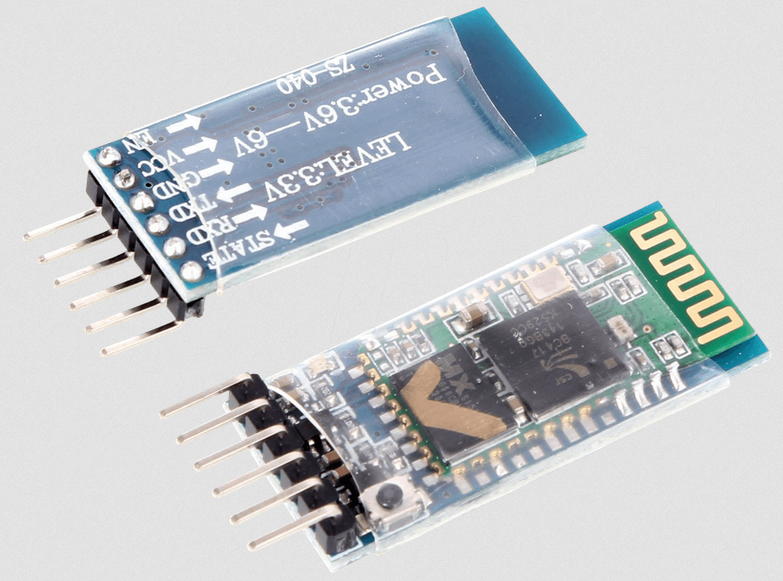

HC-05 Bluetooth Module Interfacing with Microcontroller

HC-05 is a Bluetooth device used for wireless communication with Bluetooth enabled devices (like smartphone). It communicates with microcontrollers using serial communication (USART).

Default settings of HC-05 Bluetooth module can be changed using certain AT commands.

As HC-05 Bluetooth module has 3.3 V level for RX/TX and microcontroller can detect 3.3 V level, so, there is no need to shift TX voltage level of HC-05 module. But we need to shift the transmit voltage level from microcontroller to RX of HC-05 module.

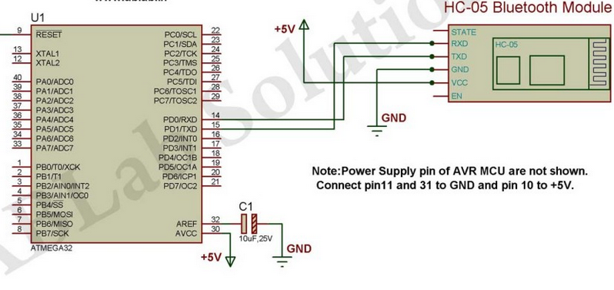

5v Relay Module

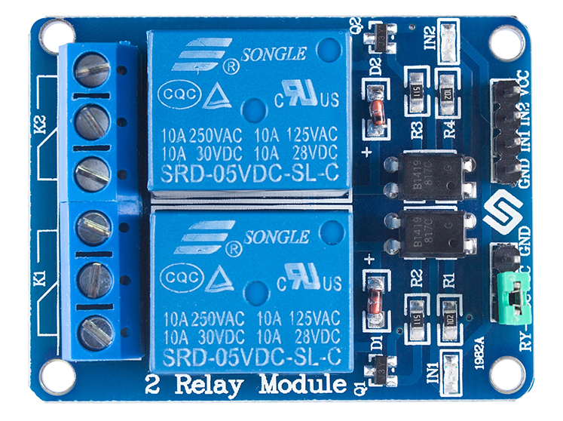

This is a LOW Level 5V 2-channel relay interface board, and each channel needs a 15-20mA driver current. It can be used to control various appliances and equipment with large current. It is equiped with high-current relays that work under AC250V 10A or DC30V 10A. It has a standard interface that can be controlled directly by microcontroller.

Features

* Relay Maximum output: DC 30V/10A, AC 250V/10A
* 2 Channel Relay Module with Optocoupler LOW Level Triger expansion board, which is compatible with arduino
* Standard interface that can be controlled directly by microcontroller ( 8051, AVR, *PIC, DSP, ARM, ARM, MSP430, TTL logic)
* Relay of high quality loose music relays SPDT. A common terminal, a normally open, one normally closed terminal
* optocoupler isolation, good anti-jamming

### Input:

VCC : Connected to positive supply voltage (supply power according to relay voltage)  
GND : Connected to negative supply voltage  
IN1: Signal triggering terminal 1 of relay module  
IN2: Signal triggering terminal 2 of relay module

### Output:

Each submodular of the relay has one NC(nomalclose), one NO(nomalopen) and one COM(Common). So there are 2 NC, 2 NO and 2 COM of the channel relay in total. NC stands for the normal close port contact and the state without power; No stands for the normal open port contact and the state with power. COM means the common port. You can choose NC port or NO port according to whether power or not.

Voltage Regulator

A **voltage regulator** is a system designed to automatically maintain a [constant voltage](https://en.wikipedia.org/wiki/Voltage_source) level. A voltage regulator may use a simple [feed-forward](https://en.wikipedia.org/wiki/Feed_forward_(control)) design or may include [negative feedback](https://en.wikipedia.org/wiki/Negative_feedback). It may use an [electromechanical mechanism](https://en.wikipedia.org/wiki/Electromechanics), or [electronic components](https://en.wikipedia.org/wiki/Electronic_component). Depending on the design, it may be used to regulate one or more [AC](https://en.wikipedia.org/wiki/Alternating_current) or [DC](https://en.wikipedia.org/wiki/Direct_current) voltages.

Electronic voltage regulators are found in devices such as computer [power supplies](https://en.wikipedia.org/wiki/Power_supply) where they stabilize the DC voltages used by the processor and other elements. In automobile [alternators](https://en.wikipedia.org/wiki/Alternator) and central [power station](https://en.wikipedia.org/wiki/Power_station) generator plants, voltage regulators control the output of the plant. In an [electric power distribution](https://en.wikipedia.org/wiki/Electric_power_distribution) system, voltage regulators may be installed at a [substation](https://en.wikipedia.org/wiki/Electrical_substation) or along [distribution lines](https://en.wikipedia.org/wiki/Electric_power_distribution) so that all customers receive steady voltage independent of how much power is drawn from the line.

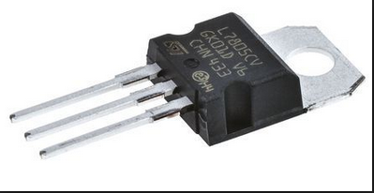

A simple voltage/current regulator can be made from a resistor in series with a [diode](https://en.wikipedia.org/wiki/Diode) (or series of diodes). Due to the logarithmic shape of diode V-I curves, the voltage across the diode changes only slightly due to changes in current drawn or changes in the input. When precise voltage control and efficiency are not important, this design may be fine. Since the forward voltage of a diode is small, this kind of voltage regulator is only suitable for low voltage regulated output. When higher voltage output is needed, a [zener diode](https://en.wikipedia.org/wiki/Zener_diode) or series of zener diodes may be employed. Zener diode regulators make use of the zener diode's fixed reverse voltage, which can be quite large.

Feedback voltage regulators operate by comparing the actual output voltage to some fixed reference voltage. Any difference is amplified and used to control the regulation element in such a way as to reduce the voltage error. This forms a [negative feedback](https://en.wikipedia.org/wiki/Negative_feedback) [control loop](https://en.wikipedia.org/wiki/Control_theory); increasing the [open-loop gain](https://en.wikipedia.org/wiki/Open-loop_gain) tends to increase regulation accuracy but reduce stability.

Crystal Oscillator

A crystal oscillator is an [electronic oscillator](https://en.wikipedia.org/wiki/Electronic_oscillator) circuit that uses the mechanical [resonance](https://en.wikipedia.org/wiki/Resonance) of a vibrating [crystal](https://en.wikipedia.org/wiki/Crystal) of [piezoelectric material](https://en.wikipedia.org/wiki/Piezoelectricity#Materials) to create an electrical signal with a precise [frequency](https://en.wikipedia.org/wiki/Frequency). This frequency is often used to keep track of time, as in [quartz wristwatches](https://en.wikipedia.org/wiki/Quartz_clock), to provide a stable [clock signal](https://en.wikipedia.org/wiki/Clock_signal) for [digital](https://en.wikipedia.org/wiki/Digital_data) [integrated circuits](https://en.wikipedia.org/wiki/Integrated_circuits), and to stabilize frequencies for [radio transmitters](https://en.wikipedia.org/wiki/Radio_transmitter) and [receivers](https://en.wikipedia.org/wiki/Radio_receiver). The most common type of piezoelectric resonator used is the [quartz](https://en.wikipedia.org/wiki/Quartz) crystal, so oscillator circuits incorporating them became known as crystal oscillators, but other piezoelectric materials including polycrystalline ceramics are used in similar circuits.

A crystal oscillator, particularly one made of [quartz crystal](https://en.wikipedia.org/wiki/Quartz), works by being distorted by an [electric field](https://en.wikipedia.org/wiki/Electric_field) when [voltage](https://en.wikipedia.org/wiki/Voltage) is applied to an [electrode](https://en.wikipedia.org/wiki/Electrode) near or on the crystal. This property is known as [electrostriction](https://en.wikipedia.org/wiki/Electrostriction) or inverse piezoelectricity. When the field is removed, the quartz - which oscillates in a precise frequency - generates an electric field as it returns to its previous shape, and this can generate a voltage. The result is that a quartz crystal behaves like an [RLC circuit](https://en.wikipedia.org/wiki/RLC_circuit).

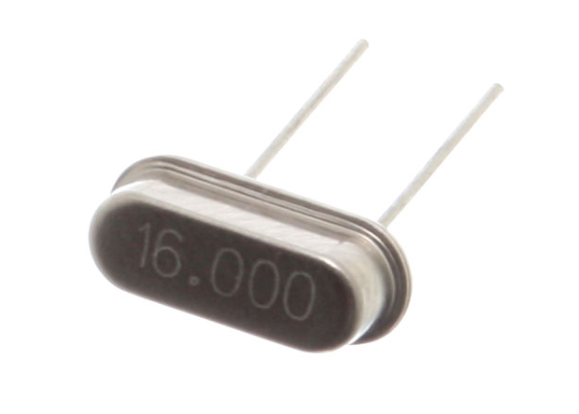

Quartz crystals are manufactured for frequencies from a few tens of [kilohertz](https://en.wikipedia.org/wiki/Kilohertz) to hundreds of megahertz. More than two billion crystals are manufactured annually. Most are used for consumer devices such as [wristwatches](https://en.wikipedia.org/wiki/Wristwatch), [clocks](https://en.wikipedia.org/wiki/Clock), [radios](https://en.wikipedia.org/wiki/Radio), [computers](https://en.wikipedia.org/wiki/Computer), and [cellphones](https://en.wikipedia.org/wiki/Cellphone). Quartz crystals are also found inside test and measurement equipment, such as counters, [signal generators](https://en.wikipedia.org/wiki/Signal_generator), and [oscilloscopes](https://en.wikipedia.org/wiki/Oscilloscope).

Ceramic Capacitor

A ceramic capacitor is a fixed-value [capacitor](https://en.wikipedia.org/wiki/Capacitor) where the ceramic material acts as the [dielectric](https://en.wikipedia.org/wiki/Dielectric). It is constructed of two or more alternating layers of [ceramic](https://en.wikipedia.org/wiki/Ceramic) and a [metal](https://en.wikipedia.org/wiki/Metal) layer acting as the [electrodes](https://en.wikipedia.org/wiki/Electrode). The composition of the ceramic material defines the electrical behavior and therefore applications. Ceramic capacitors are divided into two application classes:

* Class 1 ceramic capacitors offer high stability and low losses for resonant circuit applications.
* Class 2 ceramic capacitors offer high [volumetric efficiency](https://en.wikipedia.org/wiki/Volumetric_efficiency#Electronics) for buffer, by-pass, and coupling applications.

Ceramic capacitors, especially multilayer ceramic capacitors (MLCCs), are the most produced and used capacitors in electronic equipment that incorporate approximately one trillion (1012) pieces per year.

Ceramic capacitors of special shapes and styles are used as capacitors for [RFI/EMI](https://en.wikipedia.org/wiki/Electromagnetic_interference) suppression, as feed-through capacitors and in larger dimensions as power capacitors for [transmitters](https://en.wikipedia.org/wiki/Transmitter).

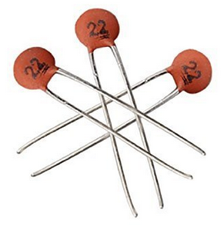

Design and Implementation

A low cost and efficient smart home system is presented in our design. This system has two main modules: the hardware interface module and the software communication module. At the heart of this system is the Arduino Mega 2560 microcontroller which is also capable of functioning as a micro web server and the interface for all the hardware modules. All communication and controls in this system pass through the microcontroller.

Designing the Circuit

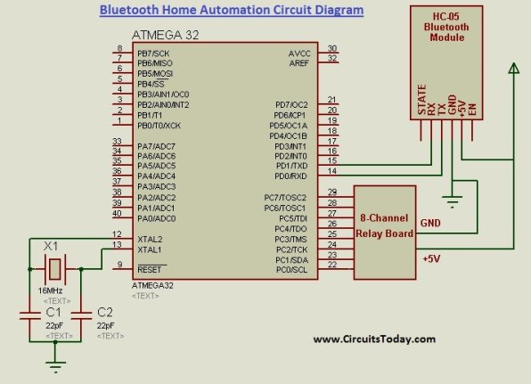

Designing the Circuit in breadboard

The circuit was designed using breadboard first. All the equipment was connected using connecting wire. This experimental connection was done by using one relay module only. The picture of the whole connection is given below:

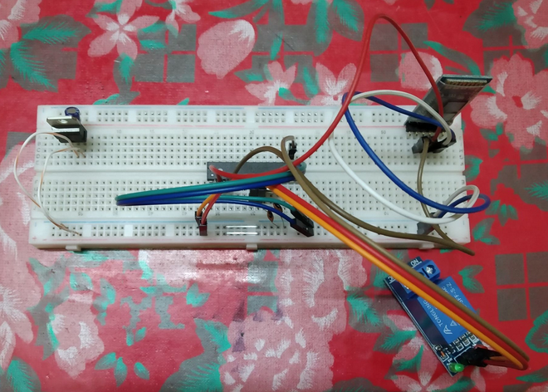

Designing in PCB

The circuit was designed using express PCB plus software. The complete design of the circuit is given below.

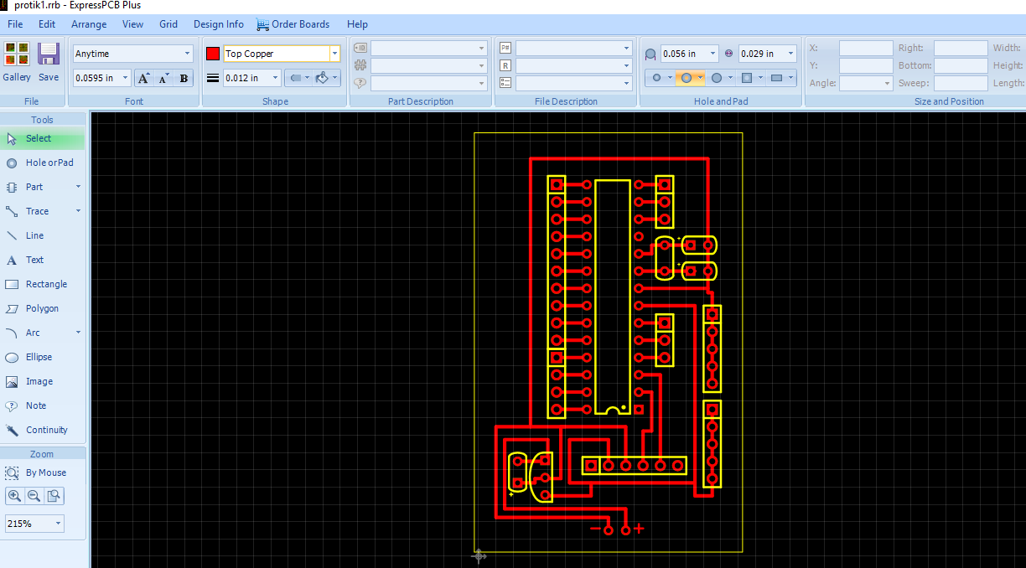

Bottom view of the PCB

The bottom view of the designed PCB board is given below

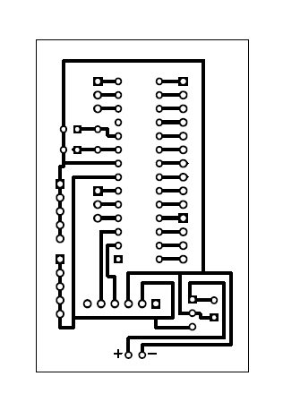

Printed Circuit Board

The circuit board was designed according to the design of express PCB layout.The picture of the printed circuit board is given below.

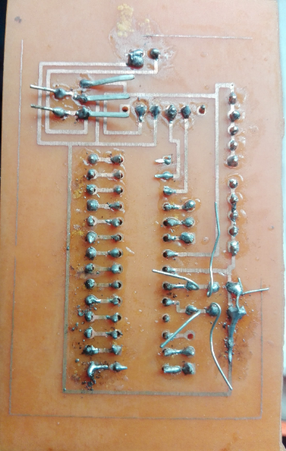

The photo is taken after sholdering the printed circuit board.

COST ANALYSIS

After completing the methodology required for the project, it is important to know about the cost incurred for each device. So, the analysis of the total cost is demonstrated below:

**Table:** Component Costs for the prototype.

|  |  |  |  |  |  |
| --- | --- | --- | --- | --- | --- |
| **SL No.** | **Components Name** | **Unit** | **Quantity** | **Unit Price**  **(BDT)** | **Total Price**  **(BDT)** |
| 1 | Atmega 328P microcontroller | Piece | 1 | 375 | 375 |
| 2 | LM35 Temperature Sensor | Piece | 1 | 300 | 300 |
| 3 | 10 mf capacitor | Piece | 1 | 5 | 5 |
| 4 | Voltage regulator | Piece | 1 | 30 | 30 |
| 5 | 16 MHz crystal Oscillator | Piece | 1 | 15 | 15 |
| 6 | 22 pf capacitor | Piece | 2 | 5 | 10 |
| 7 | 5V Relay | Piece | 5 | 90 | 450 |
| 8 | Prototyping board (Bread board) | Piece | 1 | 155 | 155 |
| 9 | Connecting wires | Piece | 40 | 3 | 120 |
| 10 | Bulb | Piece | 5 | 40 | 200 |
| 11 | Electrical wire | Piece | - | 150 | 150 |
| 12 | Cardboard for setup | Piece | 1 | 60 | 60 |
| 13 | Printing Circuit Board | Piece | 1 | 150 | 150 |
| **Total Cost (BDT)** | | | | | 2020 |

Explanation for Cost Optimization

There is Uno-R3 available in the market in which Atmega 328P microcontroller is present and many work can be done by using its functions. But for reducing cost only Atmega 328P microcontroller was used to complete this project. Other circuitry was needed to set up the Atmega 328P microcontroller which was done manually using different components. The circuit was first implemented on the bread board to check if it was right. Because if any fault was found after the circuit has been printed it would cost much to print the circuit again as printing a circuit board is not easy and costly. In addition it would cost many working hour as well. On top that some of the component cannot be used twice. So any fault in the circuit was not good for cost optimization as many component would have to be bought again. That is why bread board implementation was done. HC – 05 Bluetooth Module was chosen because it cost efficient and it has enough range to cover a home. So, HC – 05 Bluetooth Module was perfect choice for home automation project considering the cost. 5V Relay was used it has enough power to control the home circuit. So more powerful relay was not needed which was much costly.

The software in which we have designed the printed circuit board was free of cost. Also the mobile application used to control the bluetooth module was free. So no software cost was included.

Technical Specification for this project

1. A smartphone or an Android mobile which should have the android app installed in it.
2. Bluetooth receiver module – Our project will be connected to the smartphone using Bluetooth technology.
3. Controller or the main processing circuit- In this project, Arduino Uno is the main controlling / processing unit. Also, this project can be developed using PIC18F4550, AVR ATmega32 and 8051 series like: 89s51, 89c51, 89s52, 89v51RD2.
4. Relays to control devices – We have used 12volt Single push single throw relays.

6) Output devices – For the demo purpose, we connected 5 bulbs of 25 watt.

Pros of Home Automation

**1. Security**

Tap your finger to turn on the lights when you get home so you worried about what’s hiding in the shadows, or in your pathways. Or automate to turn on when you aren’t home to look like you are to ward off potential robbers. Door locks are another automated home product that can increase your home security.

**2. Energy Efficiency**

Increase your home’s energy efficiency by remotely powering off systems and appliances when they aren’t in use. In addition to the standard home automation products that give you active control, some products actively monitor systems and arm the homeowner with knowledge, insight and guidance to achieve greater control and energy efficiency.

**3. Savings**

Home automation literally pays off. When you are able to use home systems and appliances only when needed, the savings will be apparent in the first utility bill. No more wasting money on lights left on when you aren’t home, or spending money on gas to drive home because you forgot to lock the door. Monetary savings are apparent, but you’ll also be saving time. No wasted trips home, no running through the house turning everything off, no time spent worrying about what was or wasn’t turned off.

**4. Convenience**

Don’t you hate having to rely on neighbors to watch your house when you’re gone? With home automation, convenient control of your home is at your fingertips. You don’t have to trust someone else with your most valued possessions.

**5. Comfort**

Ever leave for work in the morning when it was a comfortable 68° outside only to come home to a sweltering house because the temperature shot up to 90°? Connected home products like the Sensi™ Wi-Fi Thermostats let you conveniently adjust your home temperature from the mobile app so your family is always comfortable.

Cons of Home Automation

**1. Cost of Intelligence**

Installing state-of-the-art features inside a home results in a higher price tag for the property. The cost of an intelligent home that makes our lives convenient is high because some of the technology is relatively new. The cost of living expenses such as utilities, maintenance and repair of the technology can be expensive as well.

**2. Technology Learning Curve**

Owning a smart home means having to learn how to use your home. Unlike traditional homes, smart home technology requires you to adapt to the innovations within your living area such as security systems, air units and a remote that controls your entire house. For the technology-savvy family, the smart home will help achieve convenience faster, but for others, it will take reading manuals and learning how-to before the benefits of convenience pay off.

**3. Video Surveillance**

Video surveillance can be a wonderful tool in heightening security and deterring crime, but when the technology falls into the wrong hands, issues of privacy can occur. Security sensors within the doors and walls of a smart home use wireless technology to transfer signals to a central control unit that notifies emergency officials of any foreign activity.

Applications

* Using this project, we can turn on or off appliances remotely i.e. using a phone or tablet.
* The project can be further expanded to a smart home automation system by including some sensors like light sensors, temperature sensors, safety sensors etc. and automatically adjust different parameters like room lighting, air conditioning (room temperature), door locks etc. and transmit the information to our phone.
* Additionally, we can connect to internet and control the home from remote location over internet and also monitor the safety.

Future Development of the project

* Arduino based device control using Bluetooth on Smartphone project can be enhanced to control the speed of the fan or volume of the buzzer etc.
* Home automation and Device controlling can be done using Internet of Things – IOT technology.
* We can replace Bluetooth by GSM modem so that we can achieve device controlling by sending SMS using GSM modem.

Conclusion

The home automation system has been experimentally proven to work satisfactorily by connecting sample appliances to it and the appliances were successfully controlled from a wireless mobile device. We learned many skills such as soldering, wiring the circuit and other tools that we use for this project and was able to work together as a team during this project. The Bluetooth client was successfully tested on a multitude of different mobile phones from different manufacturers, thus proving its portability and wide compatibility. Thus a low-cost home automation system was successfully designed, implemented and tested.

References

The websites that provided the informations:

* www.autogates.com.my
* www.usautomatic.com
* www.amazinggates.com
* www.microchip.co.uk
* www.quora.com
* www.engineeringproject.com
* www.efy.com
* [www.electronicsworldforyou.com](http://www.electronicsworldforyou.com)
* [www.slideshare.com](http://www.slideshare.com)
* www.electronicshub.com